

Name: ______________________ Term # ____
Homework 1- UML
(100 points) Hours:

HARCOPIES - H: The homework is to be turned in as a PAPER AND PENCIL i.e., HANDWRITTEN ANSWER ONLY unless Textual Analysis for UML Modeling is required (also Electronic - E), in the first ten minutes of the due date class.

TURNING IN THE HOMEWORK INSTRUCTIONS will be PENALTY OF -10 points.
I UNDERSTAND THAT TURNING ANOTHER’s WORK IN is CHEATING.
I UNDERSTAND THAT ANY KIND OF DISSEMINATION of this WORK is CHEATING.

I CERTIFY THAT THE HOMEWORKs SOLUTIONs ARE MY OWN WORK!
V
X
?
SIGNATURE:

HOMEWORK CHECKLIST (YOU MUST GRADE YOURSELF!):
TA check, is Homework1.doc
in BB?
- DID TURN IN HOMEWORK INSTRUCTIONS? * -10 points

1.? 10 points
2.? 10 points
3.? 10 points

4.? H & E (attach to BB) – WORD ONLY 10 points

TA checks
5.? 10 points
6.? 10 points
7.? 15 points
8.? H & E (attach to BB) – WORD ONLY 15 points
9.? 10 points

TA grade or check
- If NOT, do not enter anything in the box!

By Hand?

PLEASE ENTER YOUR GRADE IN THIS BOX:

I understand that if the .zip file is NOT in BB and I did NOT check the BOX, I will get a ZERO for this Homework!
Any DIAGRAM that is NOT the result of CUT and PASTE
WILL BE IGNORED (YOU WILL GET ZERO POINTS)

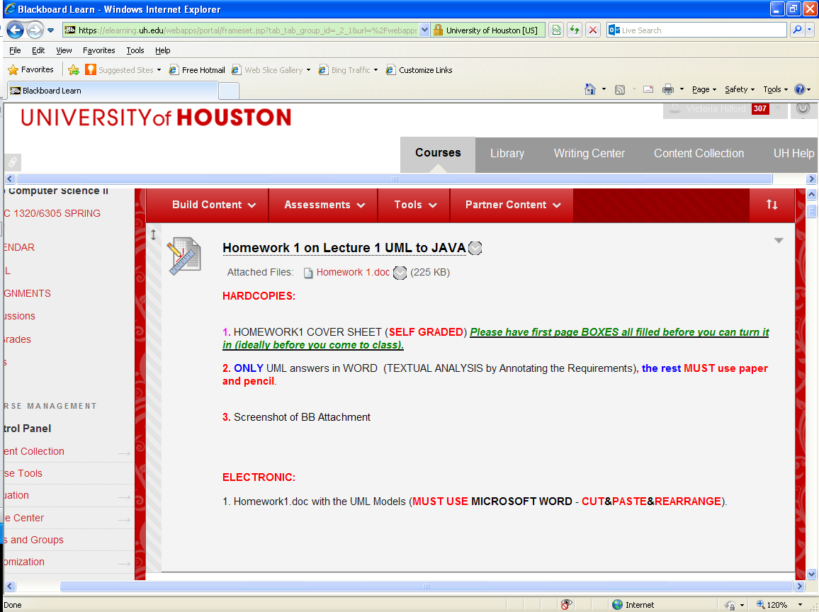
1. HOMEWORK1 COVER SHEET (SELF GRADED) Please have first page BOXES all filled before you can turn it in (ideally before you come to class).

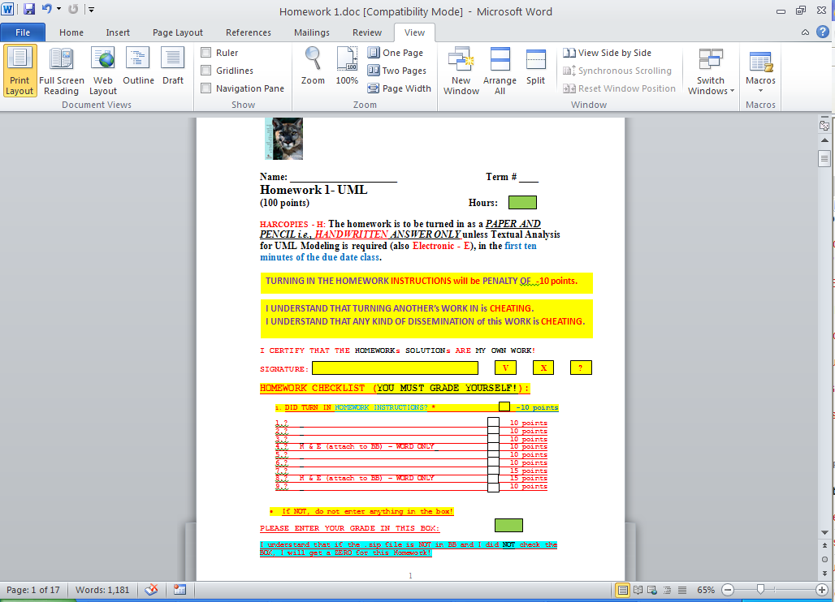

Please do not change the file name;
Must be named
Homework1.doc

3. Screenshot of BB Attachments

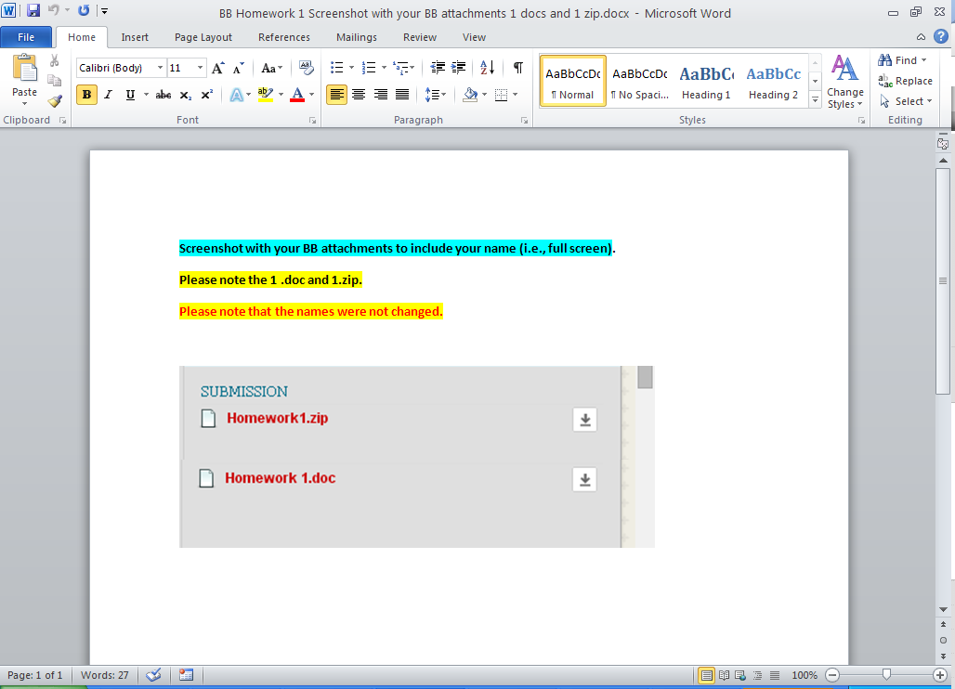

1. (10 pts.) (BY HAND):

a. In a UML diagram, the top box contains the ____.
A: member functions, parameter list, and return type of the functions
B: name of the class
C: scope of the members
D: member variables and their data types

ANSWER:

b. In OOD, the first step is to identify the components, also called ____.
A: objects
B: functions
C: conditions
D: repetition structures

ANSWER:

c. In a UML diagram, the middle box contains the ____.
A: member functions, parameter list, and return type of the functions
B: scope of the members
C: name of the class
D: member variables and their data types

ANSWER:

d. Which of the following is true of a class?
A: It grows and shrinks during program execution.
B: Its components must be of the same type.
C: It contains operations, but not data.
D: It contains both data and operations.

ANSWER:

e. In a UML diagram, a(n) ____ sign in front of a member name indicates that the member is a public member.
A: -
B: +
C: #
D: *
ANSWER:

2. (10 pts.) UML Class Diagram (BY HAND):

Describe what the following UML Class Diagram illustrates:

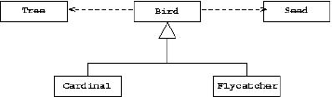

ANSWER:

3. (10 pts.) UML Sequence Diagram (BY HAND):

- Explain the purpose of an UML sequence diagram.

ANSWER:

- Describe what the following sequence UML diagram illustrates:

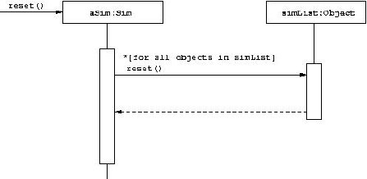
ANSWER:

4. (10 pts.) UML Class Diagram (MICROSOFT WORD; Textual Analysis – TA Cut&Paste&Rearrange).

Draw a UML Class Diagram that illustrates the following set of Classes:

A Building contains multiple Elevators, and some number of Floors. Each floor has a unique letter or number associated with it, and the floors are arranged linearly: one floor follows another in a fixed sequence. There are passenger elevators and freight elevators. Each elevator moves from one Floor to another. Riders exist either on floors or in elevators, and there are also Freight objects. Passenger elevator have a maximum number of riders permitted, freight elevators have a limit based on total weight. Riders are assumed to have a
fixed weight, but Freight objects each have an individual weight.

ANSWER:

5. (10 pts.) UML

Below is an UML Class Diagram Model
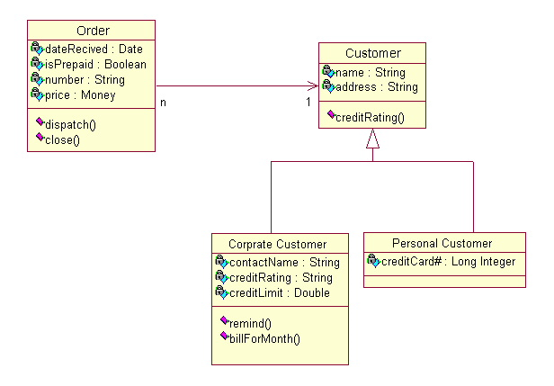
How many classes? _____

What are the classes’ names? _____________________________________________

How many instance variables are in Order? _____

How many methods are in Order? _____

What are the relationships among the classes? _________________________________

ANSWER:
6. (10 pts.) UML Class Diagram (MICROSOFT WORD; Textual Analysis – TA Cut&Paste&Rearrange):

Using the UML graphical notation for object classes, design the following object class identifying attributes and operations.

A telephone

Answer:

7. (15 pts.)
Based on the context specified, identify the most fitting UML relationship that best describes the relationship between each pair of objects or Classes given. Answer with one of the following: aggregation, association, gen/spec, instance of.

In addition, DRAW the UML Model that describes the relationship you identified (only the top section of the UML Class Model).

a. (5 pt)
Vending Machine to Vending Item

Answer:

b. (5 pt)
Student to Exam

Answer:

c. (5 pt)
Pet to Dog

Answer:

8. (15 pts.) UML Use Case Diagram (MICROSOFT WORD; Textual Analysis – TA Cut&Paste&Rearrange).

a. (5 pts)
Requirements Workflow ( UML Labeled & Numbered Use Cases Diagram )

Perform TEXTUAL ANALYSIS for a software Application that will automate a Library described below:

Every book in the Library has a bar code, a title, an author’s name, and a subject area. Every Library patron, called a borrower, has a card bearing a bar code. When a borrower wishes to check out a book, the librarian scans the bar codes on the book and the borrower’s card, and selects C on the software Application Menu (or GUI). Similarly, when a book is returned, it is again scanned and the librarian enters R on the software Application Menu (or GUI). Librarians can add or remove books (+,-) to the Library collection. Borrowers are only allowed to query catalog on all the books in the Library by a particular author (the borrower enters A= followed by the author’s name), all the books with a specific title (T= followed by the title), or all the books in a particular subject area (S= followed by the subject area). Finally, if a borrower wants a book currently checked out, the librarian can place a hold on the book, so that, when it is returned, it will be held for the borrower who requested it (H= followed by the number of the book).

For Requirements Workflow UML Labeled & Numbered Use Cases Diagram

(Mark, label and number the Actors; Mark, Label, and Number the Use Cases!)

b. (2 pts)
How many and who are the Actors?

Answer:

- (2 pts)

How many Use Cases can you identify (#)?

Answer:

- (3 pts)

Draw the UML “COMPILABLE” LABELED & NUMBERED Use Cases Diagram for the Library Application software product!

Answer:

- (3 pts) Give the Use Case Description for the return book Use Case UCx:
Answer:

9. (10 pts.) Memory

Given the following array and pointer

char array[6];
char *ptr;

array[6]
Address Array Contents
0x5010 a
0x5011 b
0x5012 F
0x5013 H
0x5014 X
0x5015 Y
1. Write a C assignment statement to initialize the
pointer ptr and make it point to the first element of the array?
_______________ or________
_______ _______________

2. What are the values of the following?
&array[0]? _____ _______ (ptr+ 3)? _____ _____________
array[0]?_________ __________ *(ptr + 3)?_________ ______________
*ptr? ____________ __________ &array[3]?_________ _________
(*ptr)+2?_________ _________ *(array+3)?_________ _____________

